Press release

25 July 2019

AIIB, EBRD and BSTDB co-finance expansion of Turkey’s largest geothermal power plant
EFELER plant adds three new units
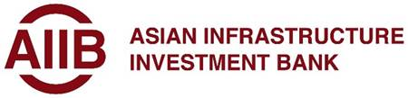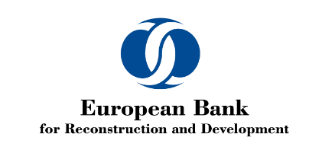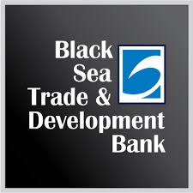

- EFELER, Turkey’s largest geothermal power plant, adds almost 100 MW in installed capacity
- Six lenders, including three development banks, provide US$ 350 million financing package to Güriş Holding’s geothermal subsidiary
- Financing part of effort to help Turkey generate energy from local, renewable sources

Three major development banks are helping Turkey diversify its energy mix with an investment adding close to 100 MW in capacity to EFELER, the country’s largest geothermal power plant.
The Asian Infrastructure Investment Bank (AIIB), the European Bank for Reconstruction and Development (EBRD) and the Black Sea Trade and Development Bank (BSTDB) are contributing to a financial package worth US$ 350 million for three new units at the plant.
EFELER is located in western Turkey, in the region of the Büyük Menderes Graben basin, the area in Turkey with the greatest potential for geothermal energy.
Gürmat Elektrik, a renewable energy subsidiary of Güriş Holding, is using the finance for the expansion at EFELER that will tap into locally available geothermal resources.
Of the three new units, EFE-6 with 22.6 MW capacity and EFE-7 with 25 MW are already operational. EFE-8 with a capacity of 50 MW is still under construction.
When fully completed next year, the plant’s eight units will have a total installed capacity of 260 MW.
Under the financing package, Gürmat Elektrik will receive US$ 100 million loan from the AIIB, a US$ 60 million loan from the EBRD and US$ 20 million loan from the BSTDB.
In parallel, Turkey’s largest commercial lender Isbank is providing US$ 90 million loan, and the Industrial Development Bank of Turkey TSKB and ICBC Turkey are making loans of US$ 50 million and US$ 30 million, respectively.
The financing is part of the effort to help Turkey develop local renewable energy sources and encourage private sector investment in the energy sector. Güriş Holding has also committed to providing more career opportunities for women in this traditionally male-dominated sector.
“This project represents a number of firsts for AIIB: EFELER is our first non-sovereign-based financing in Turkey, our first co-financing with the EBRD and the BSTDB in the private sector, and our first foray in the geothermal space,” says AIIB’s Vice President and Chief Investment Officer D.J. Pandian. “This project is a visible example of AIIB’s commitment to the expansion of renewable energy projects led by the private sector in Turkey. We are very glad to partner with Güriş Holding and our co-financiers in this important transaction.”
Nandita Parshad, EBRD Managing Director for Sustainable Infrastructure, said: “We are pleased to build on our previous cooperation with Güriş Holding, a long-standing client of the EBRD with a strong track record of project implementation. We are also proud to join forces with AIIB, BSTDB and several commercial banks and together provide a comprehensive financing package to the company. The EBRD is committed to helping Turkey develop and diversify its energy mix.”
“As a regional development bank, BSTDB seeks to considerably increase its strategic role in supporting infrastructure investments with high development impact in member countries, including creation of long-term employment and increased revenues for the state budget. This project is also a good example of our synergies with peer development institutions and the private-sector investors to increase the efficiency of development financing,” said Hasan Demirhan, BSTDB Vice President Banking.
************************************
AIIB is a multilateral development bank with a mission to improve social and economic outcomes in Asia. Headquartered in Beijing, it began operations in January 2016 and has now grown to 100 approved members worldwide. By investing in sustainable infrastructure and other productive sectors in Asia and beyond, AIIB will better connect people, services and markets that over time will impact the lives of billions and build a better future.
The EBRD is a multilateral bank that promotes the development of the private sector and entrepreneurial initiative in 38 economies across three continents. The Bank is owned by 69 countries as well as the EU and the EIB. The Bank is a leading institutional investor in Turkey and has invested over €11 billion in 283 projects in the country since 2009. The overwhelming majority of EBRD investments in Turkey are in the private sector.
The BSTDB is an international financial institution established by Albania, Armenia, Azerbaijan, Bulgaria, Georgia, Greece, Moldova, Romania, Russia, Turkey and Ukraine. The BSTDB headquarters are in Thessaloniki, Greece. BSTDB supports economic development and regional cooperation by providing loans, credit lines, equity and guarantees for projects and trade financing in the public and private sectors in its member countries.

AIIB contact: Ricardo Z. Dunn
Tel: +86 10 8358 0951
Email: ricardo.dunn@aiib.com
Twitter: @AIIB_Official

EBRD contact: Olga Rosca
Tel: +90 5498124132
Email: olga.rosca@ebrd.com
Twitter: @olgarosca @EBRD

BSTDB contact: Haroula Christodoulou
Tel: +30 2310 290533
E-mail: cchristodoulou@bstdb.org
Twitter: @BSTDB

