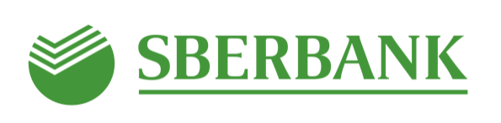

Sberbank launches its physical commodities trading company in Switzerland

- Sber Trading Swiss AG will become an essential international addition to the existing local physical commodities infrastructure of Sberbank Group.
- Sber Trading Swiss AG will focus on physical commodities trading in oil and oil products, coal, base metals, bulk and agriculture.

May 29, 2020, Moscow — Sberbank continues to expand its presence in commodities markets and opens its trading company in Zug, Switzerland.
Sber Trading Swiss AG will become the main hub of Sberbank's international physical commodity trading.

The opening of the office in Zug has become a key addition to the existing physical Commodity trading infrastructure in precious metals (PAO Sberbank), and the local physical trading house (OOO SB Commodities Trading).

Sber Trading Swiss AG will focus on international physical commodity trading in oil and oil products, coal, base metals, bulk and agriculture products.
The company’s strategy is to build on existing customer relationship between Sberbank and commodity producers and consumers in Russia and the CIS. It will allow Sberbank Group to scale up and diversify its presence in physical commodities markets.

Sber Trading Swiss AG is offering its clients the following products:
- International purchase and sale of physical commodities, including storage, transportation and distribution;
- International commodity financing through prepayment and deferred payment structures;
- Monetization of reserves (Commodity REPO) for oil and crude oil products, base metals, bulk and agricultural products.

Anatoly Popov, Deputy Chairman of the Executive Board, Sberbank,

“By opening our own International trading company we have moved to a new level in physical commodity trading. We expect Sber Trading Swiss AG to strengthen our position as one of the largest providers of solutions for our clients in international and local commodity trading, structural financing and strategic hedging. The company will focus on international trading in oil and oil products, coal, base metals, bulk and agricultural products. We are planning to work primarily with the Sberbank clients, producers and consumers of raw materials in Russia and the CIS countries, and expect the first transactions to be conducted in the third quarter of this year”.

Denis Lunin was appointed as CEO of the company. Previously Denis was responsible for physical commodities and fixed income business development in a number of Russian and international banks.

# # #
Sberbank
Polina Trizonova
Press office
Tel.: +7 495 957 5721
media@sberbank.ru

Sberbank is Russia’s largest bank and a leading global financial institution. Sberbank holds almost one-third of aggregate Russian banking sector assets, it is the key lender to the national economy and the biggest deposit taker in Russia. The Government of the Russian Federation represented by the Ministry of Finance of the Russian Federation is the principal shareholder of Sberbank owning 50% plus one voting share of the bank’s authorized capital, with the remaining 50% minus one share held by domestic and international investors. Sberbank has customers in 18 countries. Sberbank has the largest distribution network in Russia with about 14,000 branches, while its international operations – subsidiary banks, branches, and chapters – include the UK, US, CIS, Central and Eastern Europe, India, China, and other countries.
The bank holds general banking license No. 1481 issued by the Bank of Russia.
Official websites of the Bank: www.sberbank.com (Sberbank Group website), www.sberbank.ru.

